**5G IoT Based E-Textile Anti-Kidnapping Device**

A Panacea to the ongoing kidnappings

I Sulaiman Muhammad Adejo, Lead designer of the work titled "5G based IoT E-Textile Anti-Kidnapping Device" and hereafter submitted under IoTHackathon2021, declare in my name and on behalf of all co-members that we retain the ownership of all intellectual property rights on the above mentioned work.

**1.1 Problem Statement**

# What the arena is seeing approximately is the deterioration of public protection across all states of the federation and a spike in the number of kidnappings of both individuals and students. Kidnapping of students and other individuals in some part of the country have become the story of the day. Here are some media information regarding the subject matter. ‘Over 1,000 Students Kidnapped In Northern Nigerian Schools Since December 2020’ [1]. ‘Nigeria records 111 kidnapping cases in 8 months’ [2]. More than 200 children remain abducted in Nigeria amid ‘kidnap epidemic’ [3]. ‘Senior state official in Nigeria kidnapped by gunmen’ [4]. ‘One kidnapped student dead, seven rescued in Nigeria’s Kebbi state’, the army says [5]. To these end, we came up with a novel approach to mitigate the number of rampant kidnappings using a digital system to conform with the federal government digital transformation agenda towards realizing a digital economy.

**Proposed Solution and its working principle**

An IoT based 5G e-textile anti-kidnapping device that remotely sends real-time location of the victim to the guardian responsible for receiving the information using an App that will be designed. It does so according to some data collected from the device which include fluctuating heart rate of victim, accelerometer sensing an unusual increase in speed and an emergency button pressed by the victim signifying that he/she is in danger so that the necessary action would be taken. This location is received by the parent or guardian and sent to the nearest security agency within the location of the tracked data. The device will be flexible such that it can be sewed laying on the vest or underwear. The system uses the following components:

1. Microcontroller
2. GPS module
3. Accelerometer
4. Heart rate sensor
5. SOS button
6. Mobile App

**Roadmap to Deployment**

**Proof of concept**

1. **Device Block Diagram**

Below is the device block diagram of the system. It shows how the communication is between the microcontroller and the other sensors.

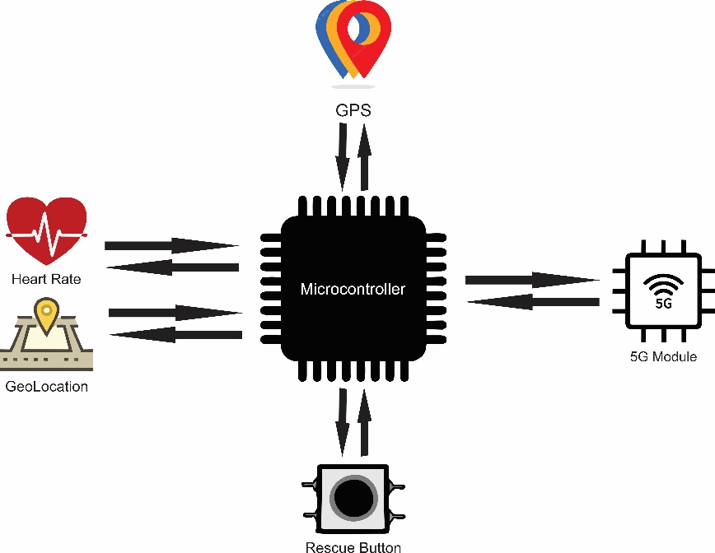

Figure 1. Device Block Diagram

1. **State Transition Diagram**

The system has 4 variables. Button, Heart Rate, Acceleration and Geolocation. It has 2 states, the Normal State which is when the system is not triggered and the Abnormal State which only activates when the system is triggered by some parameters which we will explain below. Below is the State Transition Diagram of the system.

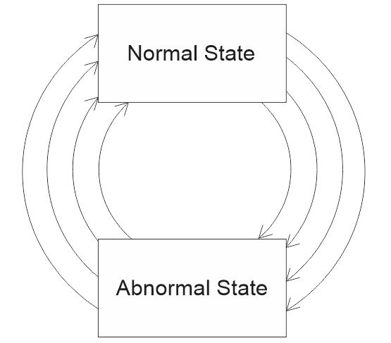

Figure 2. State Transition Diagram

**Normal State**

Here, the system is not triggered meaning the individual is safe. The location will be read at an interval say 20minutes to be able to know the individual’s whereabouts. values from the heart rate sensor and accelerometer are also read because its only when its read that the system is able to detect if its beyond the set range.

**Abnormal State**

For the system to be in this state it means the individual is in danger. The location will read at an interval of maximum a minute or less to be able to track the movements of the kidnappers. A notification will be sent to the App notifying the user that the individual is in danger. It also sends SMS to the registered mobile number. Finally, it activates the audio in order for the user to hear the happenings at the victim’s location.

1. **Android/iOS App**

The App will be used to communicate in real time with the system. It will permit the user to view information about the device like locating it on Google Maps and also take action like sending location of the victim to the nearest security agency, listen to audio from victim. Below is a high level wireframe of how the app would look like.

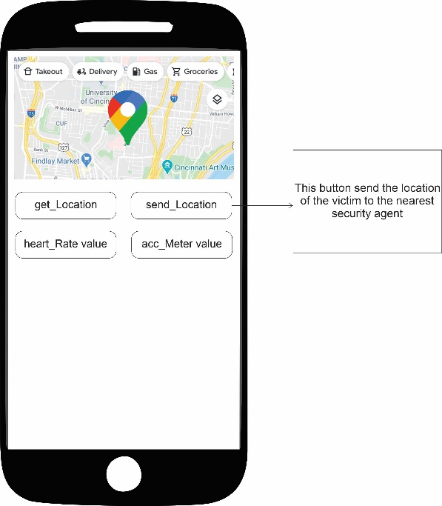

Figure 3. High Level Wireframe of App.

1. **Positioning and nature of the device**

Below is how the proposed system would look like showing possibility that it can be as invisible as possible to the kidnappers,

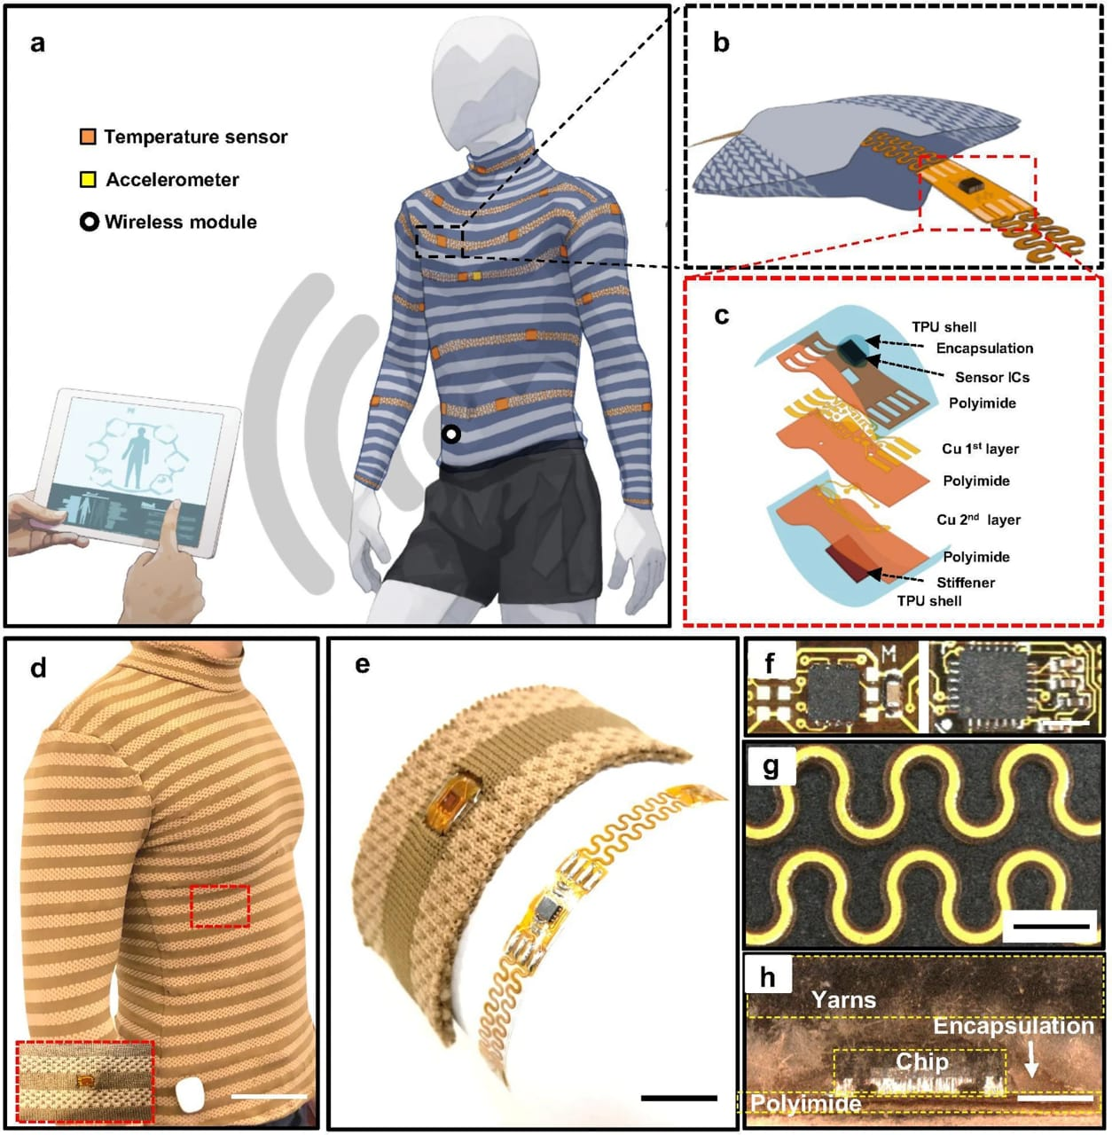

Figure 4: A pictorial view of our novel solution

**Project Timeline**



**Project Deliverables**

Stage 1: Hardware purchase and assembly.

Stage 2: Software Coding.

Stage 3: Implementation, testing and deployment.

**Limitations**

The device has some little limitations which can be capitalized and worked on in the future. Reduction of the device size to a wearable device that can lay and be stitched laying on the vest or underwear. Bad or entirely absent network in some parts of the country is also another factor that will need to be considered. Cost of the device would be high due to the use of emerging technologies e.g 5G.

**Team Members Profile**

** **

Sulaiman Muhammad Adejo. Hagos Abdallah Jemal.

34 years old. 22 years old.

500 level Electrical Electronics Engineering Student. 500 level Electrical Electronics Engineering Student.

University of Jos. University of Jos.

07030092000 08139794612

[Adejo88@gmail.com](mailto:Adejo88@gmail.com) hagosabdallah99@gmail.com

CEO Great Minds Nig Ltd. CTO Great Minds Nig Ltd.

# References

|  |  |
| --- | --- |
| [1] | S. Reporters, 24 June 2021. [Online]. Available: http://saharareporters.com/2021/06/24/over-1000-students-kidnapped-northern-nigerian-schools-december-2020-%E2%80%94-report. [Accessed 2021 September 2021]. |
| [2] | Vanguard, 15 August 2021. [Online]. Available: https://www.vanguardngr.com/2021/08/nigeria-records-111-kidnapping-cases-in-eight-months/. [Accessed 24 September 2021]. |
| [3] | T. Guardian, 10 August 2021. [Online]. Available: https://www.theguardian.com/world/2021/aug/10/more-than-200-children-remain-abducted-in-nigeria-amid-kidnap-epidemic. [Accessed 24 September 2021]. |
| [4] | aa, 08 August 2021. [Online]. Available: https://www.aa.com.tr/en/africa/senior-state-official-in-nigeria-kidnapped-by-gunmen/2329469 .. [Accessed 24 September 2021]. |
| [5] | Reuters, 18 June 2021. [Online]. Available: https://www.reuters.com/world/africa/one-kidnapped-student-dead-seven-rescued-nigerias-kebbi-state-army-says-2021-06-18/.. [Accessed 24 September 2021]. |